INTRODUCTION TO HTML

INTRODUCTION TO HTML 5
Introduction: HTML stands for Hyper Text Markup Language. It is used to design web pages using markup language. HTML is the combination of Hypertext and Markup language. Hypertext defines the link between the web pages. Markup language is used to define the text document within tag which defines the structure of web pages. HTML 5 is the fifth and current version of HTML. It has improved the markup available for documents and has introduced application programming interfaces(API) and Document Object Model(DOM).
Features:
It has introduced new multimedia features which supports audio and video controls by using <audio> and <video> tags.
There are new graphics elements including vector graphics and tags.
Enrich semantic content by including <header><footer>, <article>, <section> and <figure> are added.
Drag and Drop- The user can grab an object and drag it further dropping it on a new location.
Geo-location services- It helps to locate the geographical location of a client.
Web storage facility which provides web application methods to store data on web browser.
Uses SQL database to store data offline.
Allows to draw various shapes like triangle, rectangle, circle, etc.
Capable of handling incorrect syntax.
Easy DOCTYPE declaration i.e. <!doctype html>
Easy character encoding i.e. <meta charset=”UTF-8″>
New Added Elements in HTML 5:
<article>: The <article> tag is used to represent an article. More specifically, the content within the <article> tag is independent from the other content of the site (even though it can be related).
<aside>: The <aside> tag is used to describe the main object of the web page in a shorter way like a highlighter. It basically identifies the content that is related to the primary content of the web page but does not constitute the main intent of the primary page. The <aside> tag contains mainly author information, links, related content and so on.
<figcaption>: The <figurecaption> tag in HTML is used to set a caption to the figure element in a document.
<figure>: The <figure> tag in HTML is used to add self-contained content like illustrations, diagrams, photos or codes listing in a document. It is related to main flow but it can be used in any position of a document and the figure goes with the flow of the document and if remove it then it should not affect the flow of the document.
<header>: It contains the section heading as well as other content, such as a navigation links, table of contents, etc.
<footer>: The <footer> tag in HTML is used to define a footer of HTML document. This section contains the footer information (author information, copyright information, carriers etc). The footer tag are used within body tag. The <footer> tag is new in the HTML 5. The footer elements require a start tag as well as an end tag.
<main>: Delineates the main content of the body of a document or web app.
<mark>: The <mark> tag in HTML is used to define the marked text. It is used to highlight the part of the text in the paragraph.
<nav>: The <nav> tag is used to declaring the navigational section in HTML documents. Websites typically have sections dedicated to navigational links, which enables user to navigate the site. These links can be placed inside a nav tag.
<section>: It demarcates a thematic grouping of content.
<details>: The <details> tag is used for the content/information which is initially hidden but could be displayed if the user wishes to see it. This tag is used to create interactive widget which user can open or close it. The content of details tag is visible when open the set attributes.
<summary>: The <summary> tag in HTML is used to define a summary for the <details> element. The <summary> element is used along with the <details> element and provides a summary visible to the user. When the summary is clicked by the user, the content placed inside the <details> element becomes visible which was previously hidden. The <summary> tag was added in HTMl 5. The <summary> tag requires both starting and ending tag.
<time>: The <time> tag is used to display the human-readable data/time. It can also be used to encode dates and times in a machine-readable form. The main advantage for users is that they can offer to add birthday reminders or scheduled events in their calender’s and search engines can produce smarter search results.
<bdi>: The <bdi> tag refers to the Bi-Directional Isolation. It differentiate a text from other text that may be formatted in different direction. This tag is used when a user generated text with an unknown directions.
<wbr>: The <wbr> tag in HTML stands for word break opportunity and is used to define the position within the text which is treated as a line break by the browser. It is mostly used when the used word is too long and there are chances that the browser may break lines at the wrong place for fitting the text.
<datalist>: The <datalist> tag is used to provide autocomplete feature in the HTML files. It can be used with input tag, so that users can easily fill the data in the forms using select the data.
<keygen>: The <keygen> tag in HTML is used to specify a key-pair generator field in a form. The purpose of <keygen> element is to provide a secure way to authenticate users. When a from is submitted then two keys are generated, private key and public key. The private key stored locally, and the public key is sent to the server. The public key is used to generate client certificate to authenticate user for future.
<output>: The <output> tag in HTML is used to represent the result of a calculation performed by the client-side script such as JavaScript.
<progress>: It is used to represent the progress of a task. It is also define that how much work is done and how much is left to download a things. It is not used to represent the disk space or relevant query.
<svg>: It is the Scalable Vector Graphics.
<canvas>: The <canvas> tag in HTML is used to draw graphics on web page using JavaScript. It can be used to draw paths, boxes, texts, gradient and adding images. By default it does not contains border and text.
<audio>: It defines the music or audio content.
<embed>: Defines containers for external applications (usually a video player).
<source>: It defines the sources for <video> and <audio>.
<track>: It defines the tracks for <video> and <audio>.
<video>: It defines the video content.
CSS INTRODUCTION
Cascading Style Sheets, fondly referred to as CSS, is a simply designed language intended to simplify the process of making web pages presentable. CSS allows you to apply styles to web pages. More importantly, CSS enables you to do this independent of the HTML that makes up each web page.
CSS is easy to learn and understood but it provides powerful control over the presentation of an HTML document.
WHY CSS?
CSS saves time : You can write CSS once and reuse same sheet in multiple HTML pages.
Easy Maintainence : To make a global change simply change the style, and all elements in all the webpages will be updated automatically.
Search Engines : CSS is considered as clean coding technique, which means search engines won’t have to struggle to “read” its content.
Superior styles to HTML : CSS has a much wider array of attributes than HTML, so you can give a far better look to your HTML page in comparison to HTML attributes.
Offline Browsing : CSS can store web applications locally with the help of offline catche.Using of this we can view offline websites.

BASIC STRUCTURE OF HTML
The <HTML> is a markup language which is used by the browser to manipulate text, images and other content to display it in required format.
Tags in HTML: Tags are one of the most important part in an HTML Document. HTML uses some predefined tags which tells the browser about content display property, that is how to display a particular given content. For Example, to create a paragraph, one must use the paragraph tags(<p></p>) and to insert an image one must use the img tags(<img />).
There are generally two types of tags in HTML:
Paired Tags: These tags come in pairs. That is they have both opening(<>) and closing(</ >) tags.
Singular Tags: These tags do not required to be closed.
Below is an example of (<b>) tag in HTML, which tells the browser to bold the text inside it.

Structure of an HTML
An HTML Document is mainly divided into two parts:
HEAD: This contains the information about the HTML document. For Example, Title of the page, version of HTML, Meta Data etc.
BODY: This contains everything you want to display on the Web Page.
Let us now have a look on the basic structure of HTML. That is the code which is must for every webpage to have:

<!DOCTYPE html>

<html>
<head>
<title>

</title>
</head>

<body>

</body>
</html>
Every Webpage must contain this code. Below is the complete explanation of each of the tags used in the above piece of HTML code:
<!DOCTYPE html>: This tag is used to tells the HTML version. This currently tells that the version is HTML 5.
<html>: This is called HTML root element and used to wrap all the code.
<head>: Head tag contains metadata, title, page CSS etc. All the HTML elements that can be used inside the <head> element are:
<style>
<title>
<base>
<noscript>
<script>
<meta>
We will learn about these in details later.
<body>: Body tag is used to enclosed all the data which a web page has from texts to links. All of the content that you see rendered in the browser is contained within this element.

DESIGNING A WEB PAGE
So far, we already have learned about the structure of an HTML document, tags etc. Let us use this knowledge to create our first web page which will print the text “Hello World!” on the screen.
Open your text editor, and type the below code in it and save it with the name “index.html”:

<!DOCTYPE html>

<html>
<head>
<title>
First Web Page
</title>
</head>

<body>
Hello World!
</body>
</html>
On opening the file in a web browser, you will see the below output:
Yes, it’s that easy to print anything on the Web Page. You don’t need to compile your HTML code to run it in an Web Page. As HTML is an scripting language, you can simply change your code and hit the referesh button and the changes will be reflected to your Web page immediately.

Make “Hello World!” Bigger: The text “Hello World!” seems to appear small. Let us make it look a bit more bigger.
We have seen usage of <h1/> tags in our previous articles. This is a heading tag in HTML which is used to represent headings in a Web Page.
Heading Tags: There are six levels of headings defined by HTML. These six heading
elements are H1, H2, H3, H4, H5, and H6; with H1 being the highest level and H6 the least.
Let us use these six different Heading tags separately to print “Hello World!” and see the difference. Modify your code in index.html with the below code:

<!DOCTYPE html>

<html>
<head>
<title>
First Web Page
</title>
</head>

<body>
<h1>Hello World!</h1>
<h2>Hello World!</h2>
<h3>Hello World!</h3>
<h4>Hello World!</h4>
<h5>Hello World!</h5>
<h6>Hello World!</h6>
</body>
</html>
On refreshing the web page you will see the output will change to:
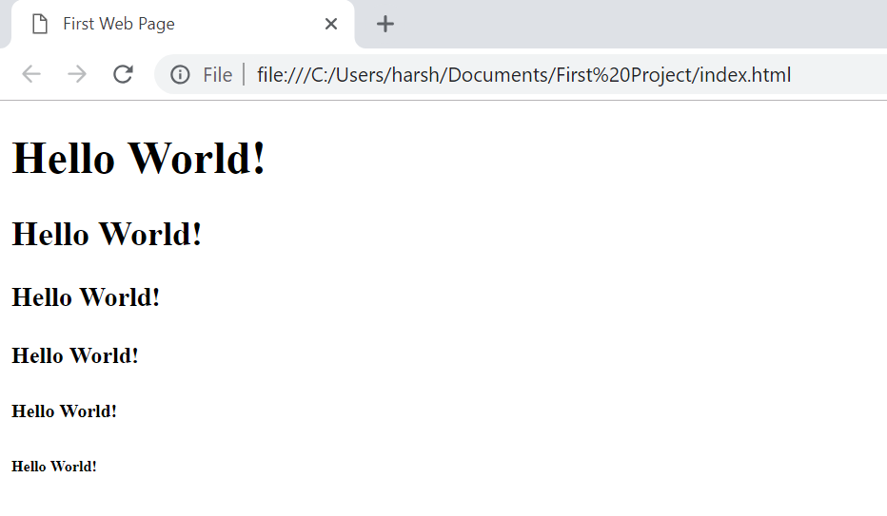

INSERTING ELEMENTS

LINKS
HTML links are hyperlinks.
You can click on a link and jump to another document.
When you move the mouse over a link, the mouse arrow will turn into a little hand.
Note: A link does not have to be text. A link can be an image or any other HTML element!

Syntax
The HTML <a> tag defines a hyperlink. It has the following syntax:
<a href="url">link text</a>
The most important attribute of the <a> element is the href attribute, which indicates the link's destination.
The link text is the part that will be visible to the reader.

IMAGES
The HTML <img> tag is used to embed an image in a web page.
Images are not technically inserted into a web page; images are linked to web pages. The <img> tag creates a holding space for the referenced image.
The <img> tag is empty, it contains attributes only, and does not have a closing tag.
The <img> tag has two required attributes:
src - Specifies the path to the image
alt - Specifies an alternate text for the image
Syntax
<img src="url" alt="alternatetext">

HORIZONTAL RULES
The <hr> tag defines a thematic break in an HTML page (e.g. a shift of topic).
The <hr> element is most often displayed as a horizontal rule that is used to separate content (or define a change) in an HTML page.

COMMENTS
<!--This is a comment. Comments are not displayed in the browser-->
<p>This is a paragraph.</p>

The comment tag is used to insert comments in the source code. Comments are not displayed in the browsers.
You can use comments to explain your code, which can help you when you edit the source code at a later date. This is especially useful if you have a lot of code.

FORMATTING TEXT
Formatting elements were designed to display special types of text:
<b> - Bold text
<strong> - Important text
<i> - Italic text
<em> - Emphasized text
<mark> - Marked text
<small> - Smaller text
<del> - Deleted text
<ins> - Inserted text
<sub> - Subscript text
<sup> - Superscript text

TITLE
Definition and Usage
The <title> tag defines the title of the document. The title must be text-only, and it is shown in the browser's title bar or in the page's tab.
The <title> tag is required in HTML documents!
The contents of a page title is very important for search engine optimization (SEO)! The page title is used by search engine algorithms to decide the order when listing pages in search results.
The <title> element:
defines a title in the browser toolbar
provides a title for the page when it is added to favorites
displays a title for the page in search-engine results
TABLE
Define an HTML Table
The <table> tag defines an HTML table.
Each table row is defined with a <tr> tag. Each table header is defined with a <th> tag. Each table data/cell is defined with a <td> tag.
By default, the text in <th> elements are bold and centered.
By default, the text in <td> elements are regular and left-aligned.
Example
A simple HTML table:
<table style="width:100%">
<tr>
<th>Firstname</th>
<th>Lastname</th>
<th>Age</th>
</tr>
<tr>
<td>Jill</td>
<td>Smith</td>
<td>50</td>
</tr>
<tr>
<td>Eve</td>
<td>Jackson</td>
<td>94</td>
</tr>
</table>

FORMS
The <form> Element
The HTML <form> element is used to create an HTML form for user input:
<form>
.
form elements
.
</form>
The <form> element is a container for different types of input elements, such as: text fields, checkboxes, radio buttons, submit buttons, etc.
All the different form elements are covered in the next chapter: HTML Form Elements.

The <input> Element
The HTML <input> element is the most used form element.
An <input> element can be displayed in many ways, depending on the type attribute.
Here are some examples:
Type | Description
<input type="text"> | Displays a single-line text input field
<input type="radio"> | Displays a radio button (for selecting one of many choices)
<input type="check"> | Displays a checkbox (for selecting zero or more of many choices)
<input type="submit"> | Displays a submit button (for submitting the form)
<input type="button"> | Displays a clickable button

Example
<form>
<label for="fname">First name:</label><br>
<input type="text" id="fname" name="fname"><br>
<label for="lname">Last name:</label><br>
<input type="text" id="lname" name="lname">
</form>

FRAME
An HTML iframe is used to display a web page within a web page.
The HTML <iframe> tag specifies an inline frame.
An inline frame is used to embed another document within the current HTML document.
Syntax
<iframe src="url" title="description">
Use the height and width attributes to specify the size of the iframe.
The height and width are specified in pixels by default:
Example
<iframe src="demo_iframe.htm" height="200" width="300" title="Iframe Example"></iframe>

